Choosing the Appropriate Number for a New Course
Florida’s State Course Numbering System
https://flscns.fldoe.org/default.aspx (no login account information required)
https://flscns.fldoe.org/LinkUploads/SCNS%202017%20Handbook%2006-01-18.pdf [SCNS Handbook]

Select the prefix within the discipline that is most closely related to the part of the specialization area. For example, the discipline of Mass Communication has 10 specialization areas designated with their own prefixes.
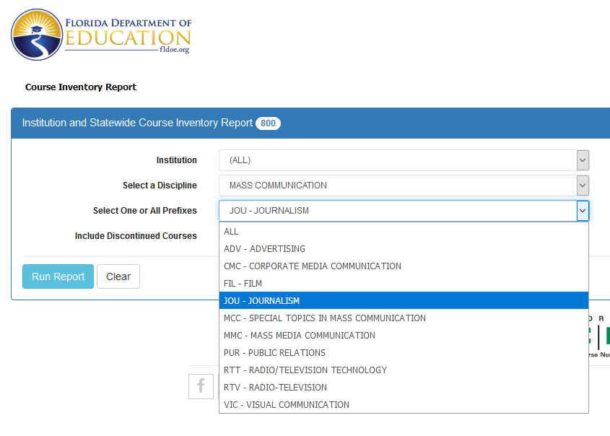

The selection of the first of the four digits that will constitute the course number is determined by the level of the course. The state requires the following codes for course levels:
“A level code, which roughly corresponds to pre-college work or the year in college the course is normally taken (i.e., freshman, sophomore, etc.), is placed between the course prefix and the course number. The level is recommended by the institution according to its own policies and the policies of the State of Florida, and approved by the faculty committee.
The level digit does not affect course equivalency—course equivalency is determined by the prefix and the last three digits. The following are the level definitions:
0 PSAV, college prep, vocational prep
1–2 Lower-level undergraduate
3–4 Upper-level undergraduate
5–9 Graduate and Professional

Courses are numbered based on content, rather than by department or program. This means that a single program may have courses in several different disciplines and may consist of courses having several different prefixes.”

The state breaks each prefix into 10 centuries. For example, Journalism (JOU) is broken into the these general categories:
X0XX Introduction and History of Journalism
X1XX Reporting
X2XX Editing/Layout
X3XX Specialty Journalism
X4XX Journalism Laboratory
X5XX Journalism Management
X6XX Photojournalism
X7XX Law & Ethics
X8XX Teaching Journalism
X9XX General Miscellaneous Categories [Independent Studies/Directed Readings and Other Specialized Offerings that are not automatically transferable between institutions]

Each century is broken into 10 decades to provide further specialization. For example, JOU X3XX courses all deal with Specialty Journalism or styles of writing, but they can be narrowed through the change of decade:
X30X Introduction to Specialty Journalism
X31X Advanced Specialty Journalism
X32X Broadcast Journalism [Television Reporting & Film]
X33X Feature Writing
X34X Multimedia Technologies
X35X Business Reporting
X36X Digital Media
X37X Social Media for Magazines
X38X [Not Currently Used for any Courses]
X39X Specialty Journalism

Individual courses then fit into the decades. This allows universities to delineate distinctions between Metro Reporting, for example, and Covering the City.
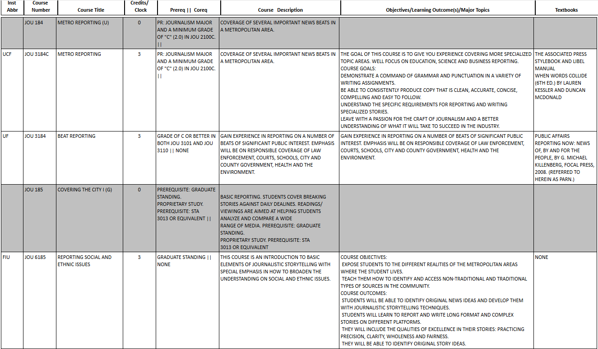
Notice the lower-level and upper-level courses are categorized by century and decade, emphasizing the content rather than the level. Thus, EFSC’s JOU 1200 [Newspaper Layout and Editing] has the same number as FIU’s JOUR 3200 –Editing and Makeup], but the level is distinct. The upper-level course has a Visual Design and Media course as a required prerequisite. Level is very important when determining a transfer credit equivalency, but it is not the determiner of the other three digits in a course number.
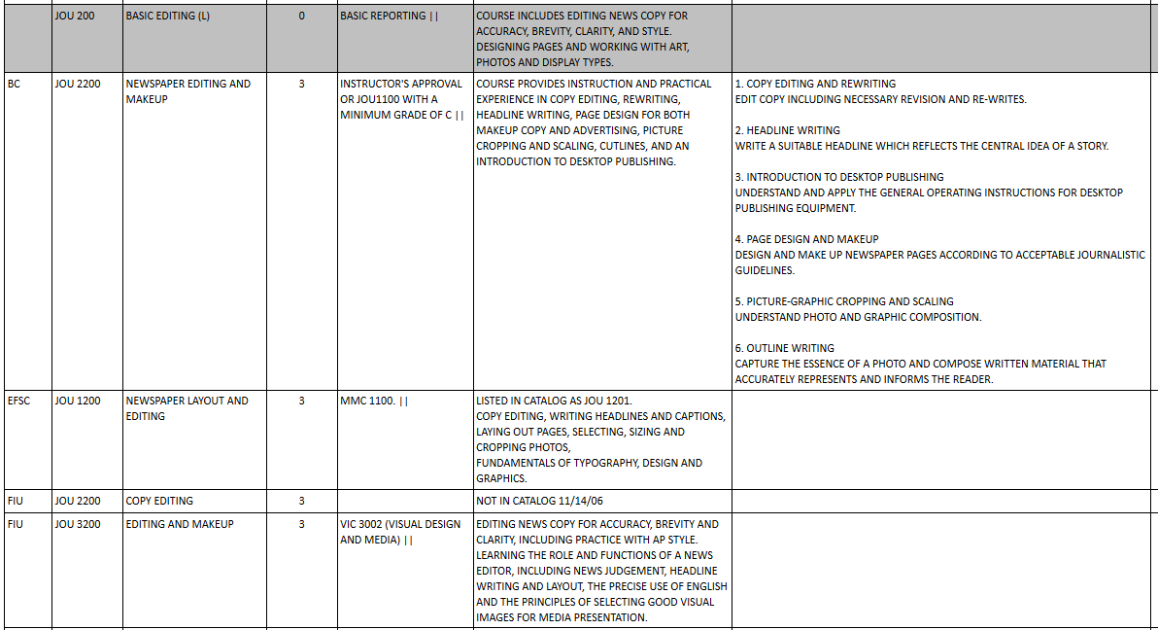
Faculty members proposing courses can view the taxonomies for their disciplines by accessing the SCNS site. No login or password is required to view taxonomies, UCF courses, or statewide courses.
https://flscns.fldoe.org/default.aspx (no login account information required)
1.)At the top of the site menu CLICK FIND A COURSE
2.)CLICK FIND A STATEWIDE COURSE
3.)CLICK on blue tab BROWSE STATEWIDE COURSE
4.)SELECT DISCIPLINE FROM DROP DOWN (Prefix and Number Range should default “ALL” and click SEARCH
This will bring you the Statewide taxonomy that lists any associated prefixes to the Discipline. Accounting has ACG, ACO,APA and Tax:
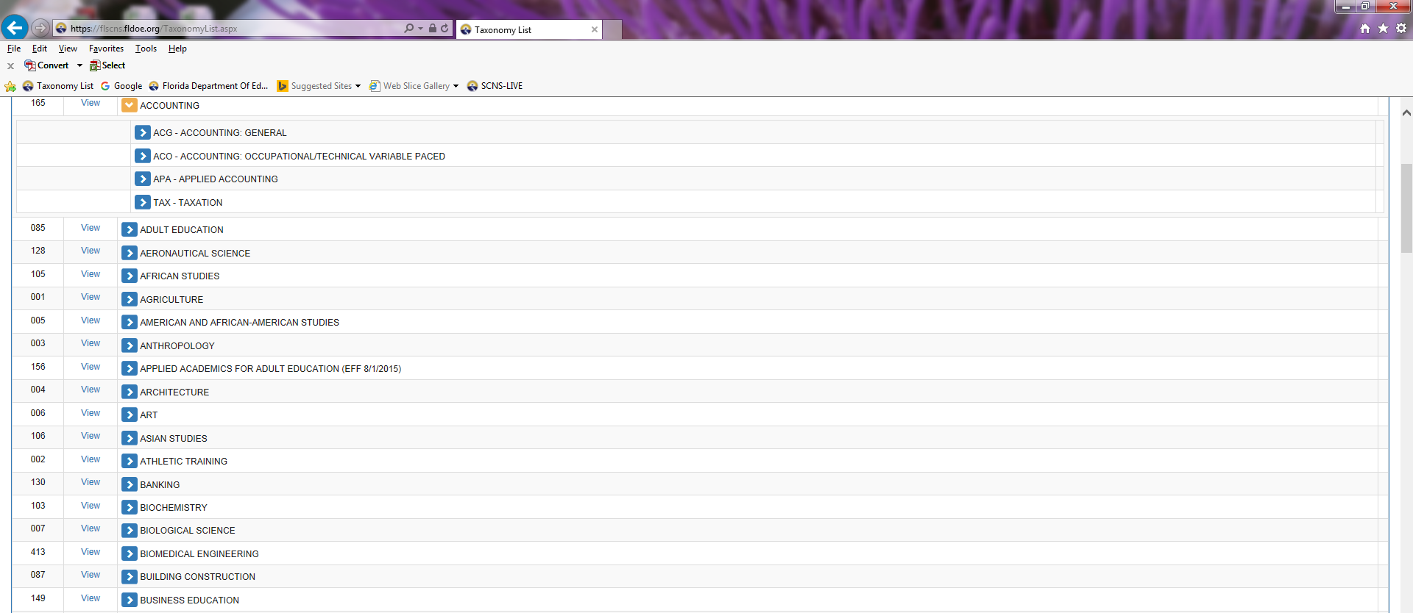
Expand ACG prefix by CLICKING on the blue arrow and that will list the centuries:
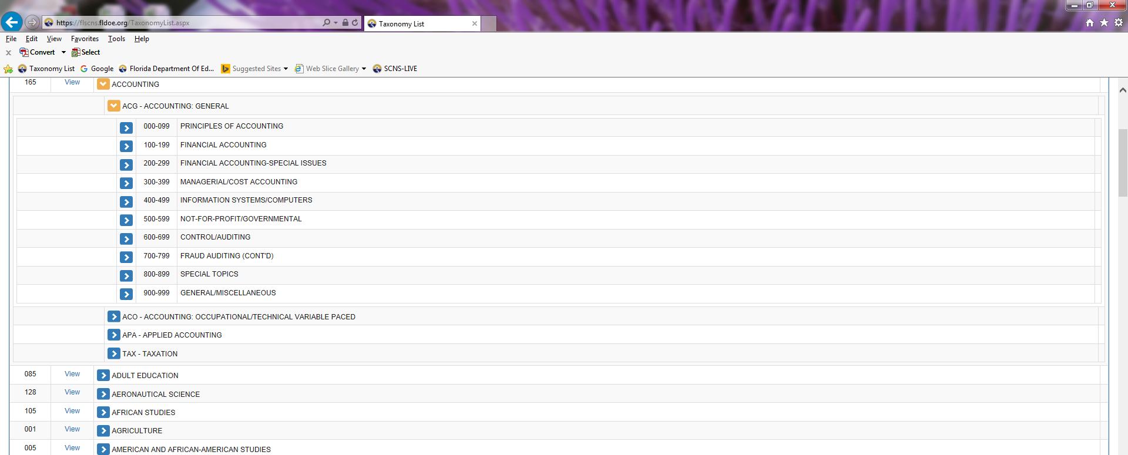
CLICK on the blue arrow again to see the decades in each century (i.e. CLICK Principles of Accounting).
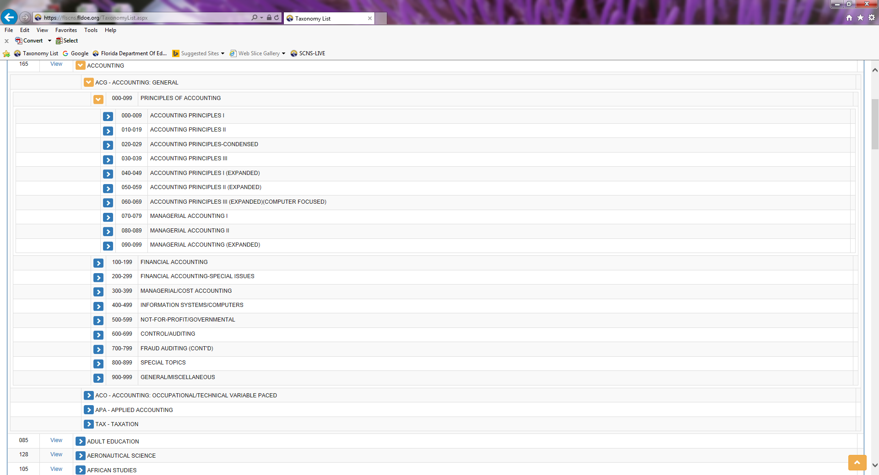

You can also see which institutions have active courses within a century, decade, or number and review those course descriptions by clicking on Find a Course, Find a Statewide Course, and selecting the Discipline and Prefix. Selecting History and WOH [World History], for example, produces six pages of offerings.
If you click on page 2, WOH 044 [which is X044 since levels are not included in the taxonomy] is in the middle of the page. Clicking on W04 044 gives you the general information about the courses in that decade. Clicking on the Institutions tab reveals that only Florida Gulf Coast University has an active course in that decade. If UCF wanted to create a new undergraduate course that focused on 20th century world history, the History Department could use the State Course Detail information along with a review of FGCU’s course to determine if its new course would fit into that number. If so, UCF could propose a new course as either WOH 3044 or WOH 4044, depending on where the course would fit into the curriculum, the prerequisites required, readings, and more.
Notice that the FGCU course includes the statement “guaranteed transfer to institution offering same course” at the bottom of the Institution Course Detail. This is an important reminder that the reason the state wants to ensure UCF’s WOH 3044 or WOH 4044 is demonstrably similar to FGCU’s course is that each institution would be required to automatically accept the other’s course for transfer credit. Therefore, the content should be ~80% the same. This is determined by course description, learning outcomes and major topics, credit hours, prerequisites, and readings. Again, the level is important in a transfer credit decision but not a course numbering decision.
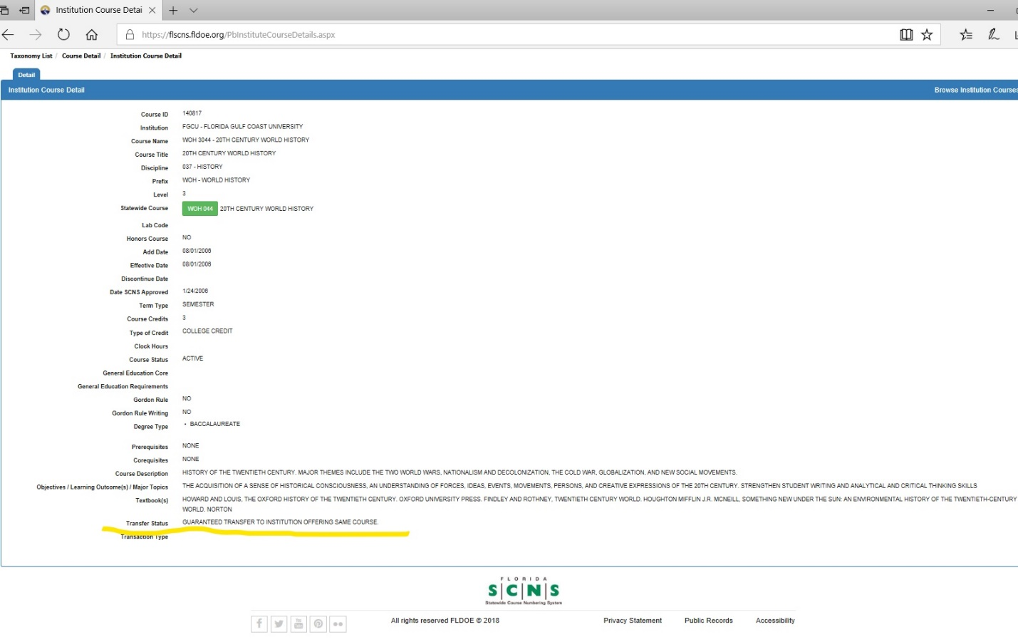

UCF Resources to Assist with the Selection of a Course Number
The following UCF faculty members serve as Discipline Coordinators (DCs) for the State Course Numbering System. They have extensive experience reviewing new course proposals from institutions across the state and are familiar with the taxonomy structure.
Dr. John Schultz – Anthropology
Dr. Seth Elsheimer – Chemistry
Dr. Florin Mihai – ESL
Dr. John Sacher – History
Dr. Bruce Janz – Humanities
Prof. George Bagley – Mass Communication
Dr. Heath Martin – Mathematics
Dr. Hyoung Jin Cho – Mechanical Engineering
Prof. Steven Spencer – Photography
Dr. Patrick Pabian – Physical Therapy
Dr. Doan Modianos – Psychology
Dr. Mary Ann Feldheim – Public Administration
Dr. Robin Kohn – Social Work
Dr. Jay Corzine – Sociology

Dr. Keisha Hoerrner, UCF’s Institutional Contact for SCNS
Ms. Danielle Hutson, UPCC/UCRC Assistant [ucrc@ucf.edu]

